Working with Nodeport Service

With Nodeport inspite of having a cluster-internal IP, it expose the service on a port on each node of the cluster (the same port on each node). We can access the service on any <NodeIP>:NodePort. If you set the type field to “NodePort”, the Kubernetes master will allocate a random port from a range (default range is 30000-32767), and each Node will proxy that port (the same port number on every Node) into your Service. You can specify the particular nodeport also.

Create A deployment from following configuration.
apiVersion: apps/v1
kind: Deployment
metadata:
name: nginx-deployment
labels:
app: nginx
spec:
replicas: 1
selector:
matchLabels:
app: nginx
template:
metadata:
labels:
app: nginx
spec:
containers:
- name: nginx-ctr
image: nginx:1.15.4
ports:
- containerPort: 80

Deploy
kubectl apply -f deploy.yaml

Create a Nodeport service by using following yaml file -nodeport.yaml
apiVersion: v1
kind: Service
metadata:
name: nginx-nodesvc
labels:
app: nginx
spec:
type: NodePort
ports:
- port: 80
nodePort: 31009
protocol: TCP
selector:
app: nginx

Deploy Nodeport service.
kubectl apply -f nodeport.yaml

Get the information of of the services present and their ports.
kubectl get svc
NAME CLUSTER-IP EXTERNAL-IP PORT(S) AGE
kubernetes 10.0.0.1 <none> 443/TCP 1h
nginx-nodesvc 10.0.0.55 <nodes> 80:31009/TCP 1m

Get the Node IP.
kubectl get node -o wide
NAME STATUS ROLES AGE VERSION EXTERNAL-IP OS-IMAGE KERNEL-VERSION CONTAINER-RUNTIME
ip-172-20-42-226.us-west-2.compute.internal Ready master 1d v1.10.3 54.201.214.249 Debian GNU/Linux 8 (jessie) 4.4.121-k8s docker://17.3.2
ip-172-20-46-21.us-west-2.compute.internal Ready node 1d v1.10.3 34.217.40.145 Debian GNU/Linux 8 (jessie) 4.4.121-k8s docker://17.3.2
ip-172-20-61-64.us-west-2.compute.internal Ready node 1d v1.10.3 35.162.251.247 Debian GNU/Linux 8 (jessie) 4.4.121-k8s docker://17.3.2

Access the node public ip with Nodeport number on both the worker Nodes and also the Master Node
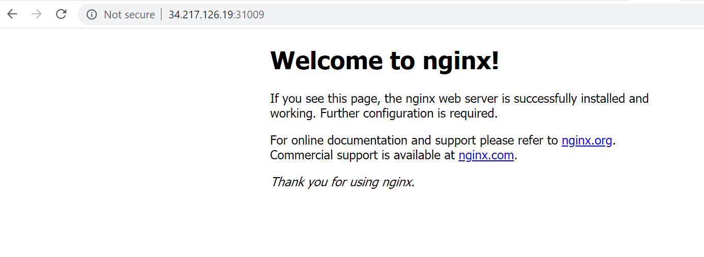
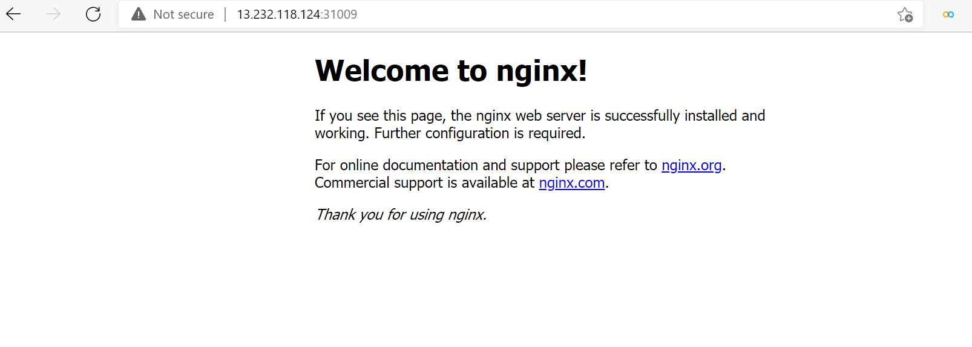
Also you can access the nginx pod via Nodeport and Node IP all the nodes from the box including Master Machine
curl 34.217.40.145:31009

<!DOCTYPE html>
<html>
<head>
<title>Welcome to nginx!</title>
<style>
body {
width: 35em;
margin: 0 auto;
font-family: Tahoma, Verdana, Arial, sans-serif;
}
</style>
</head>
<body>
<h1>Welcome to nginx!</h1>
<p>If you see this page, the nginx web server is successfully installed and
working. Further configuration is required.</p>

<p>For online documentation and support please refer to
<a href="http://nginx.org/">nginx.org</a>.<br/>
Commercial support is available at
<a href="http://nginx.com/">nginx.com</a>.</p>

<p><em>Thank you for using nginx.</em></p>
</body>
</html>

Delete the service and deployment
kubectl delete svc svcname
kubectl delete deploy deploymentname

